Skylab 4

**From Wikipedia, the free encyclopedia**

https://en.wikipedia.org/wiki/Skylab%204  
Licensed under CC BY-SA 3.0:  
https://en.wikipedia.org/wiki/Wikipedia:Text_of_Creative_Commons_Attribution-ShareAlike_3.0_Unported_License

# Skylab 4

* *The manned Skylab missions were officially designated Skylab 2, 3, and 4.*
* *Skylab 4 (also SL-4 and SLM-3) was the third manned Skylab mission and placed the third and final crew aboard the first American space station.*
* *Mis-communication about the numbering resulted in the mission emblems reading "Skylab I", "Skylab II", and "Skylab 3" respectively.*

Skylab 4 (also SL-4 and SLM-3) was the third manned Skylab mission and placed the third and final crew aboard the first American space station.

The mission started on November 16, 1973 with the launch of three astronauts on a Saturn IB rocket from the Kennedy Space Center, Florida and lasted 84 days, one hour and 16 minutes. A total of 6,051 astronaut-utilization hours were tallied by Skylab 4 astronauts performing scientific experiments in the areas of medical activities, solar observations, Earth resources, observation of the Comet Kohoutek and other experiments.

The manned Skylab missions were officially designated Skylab 2, 3, and 4. Mis-communication about the numbering resulted in the mission emblems reading "Skylab I", "Skylab II", and "Skylab 3" respectively.

# Launch

* *The name restoration to Cape Canaveral became official on October 9, 1973.The first manned launch under the name of "Cape Canaveral" was the Skylab 4 mission, on November 16, 1973.*

Cape Kennedy was named Cape Canaveral officially on October 9, 1973. The name restoration to Cape Canaveral became official on October 9, 1973.The first manned launch under the name of "Cape Canaveral" was the Skylab 4 mission, on November 16, 1973.

# Crew

* *Following the all rookie Mercury program, there were only five more all-rookie NASA flights -- Gemini 4, Gemini 7, Gemini 8, Skylab 4 and, in 1981, STS-2.*
* *With three rookies, Skylab 4 was the largest all-rookie crew launched by NASA.*

With three rookies, Skylab 4 was the largest all-rookie crew launched by NASA. Following the all rookie Mercury program, there were only five more all-rookie NASA flights -- Gemini 4, Gemini 7, Gemini 8, Skylab 4 and, in 1981, STS-2.

# Backup crew

# Support crew

* *William E. Thornton*
* *Bruce McCandless II*
* *F. Story Musgrave*
* *Robert L. Crippen*
* *Henry W. Hartsfield, Jr*
* *Richard H. Truly*
* *Russell L. Schweickart*

Robert L. Crippen

Henry W. Hartsfield, Jr

Bruce McCandless II

F. Story Musgrave

Russell L. Schweickart

William E. Thornton

Richard H. Truly

# Mission parameters

* *Maximum altitude: 440 km (273 mi) (November 16, 1973)*
* *Launch Vehicle: Saturn IB*

Mass: 20,847 kg (45,960 lb)

Maximum altitude: 440 km (273 mi) (November 16, 1973)

Total distance traveled: 34.5 million miles (55,500,000 km)

Launch Vehicle: Saturn IB

Epoch: January 21, 1974

Perigee: 422 km (262 mi)

Apogee: 437 km (272 mi)

Inclination: 50.04°

Period: 93.11 min

# Docking

* *Time Docked: 83 days, 4 hours, 38 minutes, 12 seconds*
* *Docked: November 16, 1973 – 21:55:00 UTC*

Docked: November 16, 1973 – 21:55:00 UTC

Undocked: February 8, 1974 – 02:33:12 UTC

Time Docked: 83 days, 4 hours, 38 minutes, 12 seconds

# Space walks

* *Gibson and Pogue — EVA 1*
* *Carr and Gibson — EVA 4*
* *Carr and Gibson — EVA 3*
* *Start: December 25, 1973, 16:00 UTC*
* *Start: December 29, 1973, 17:00 UTC*
* *Carr and Pogue — EVA 2*
* *Start: November 22, 1973, 17:42 UTC*

Gibson and Pogue — EVA 1

Start: November 22, 1973, 17:42 UTC

End: November 23, 00:15 UTC

Duration: 6 hours, 33 minutes

Carr and Pogue — EVA 2

Start: December 25, 1973, 16:00 UTC

End: December 25, 23:01 UTC

Duration: 7 hours, 01 minute

Carr and Gibson — EVA 3

Start: December 29, 1973, 17:00 UTC

End: December 29, 20:29 UTC

Duration: 3 hours, 29 minutes

Carr and Gibson — EVA 4

Start: February 3, 1974, 15:19 UTC

End: February 3, 20:38 UTC

Duration: 5 hours, 19 minutes

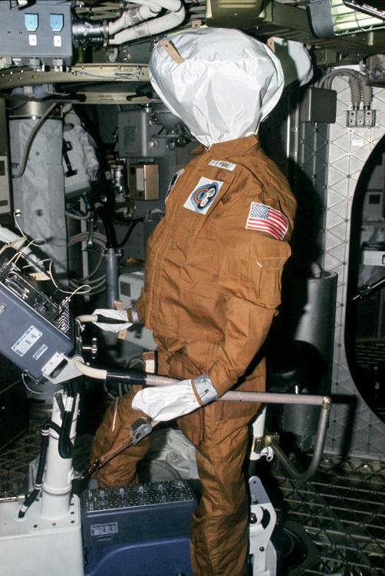  
*One of the dummies left behind by the Skylab 3 crew to be found by the Skylab 4 crew.*

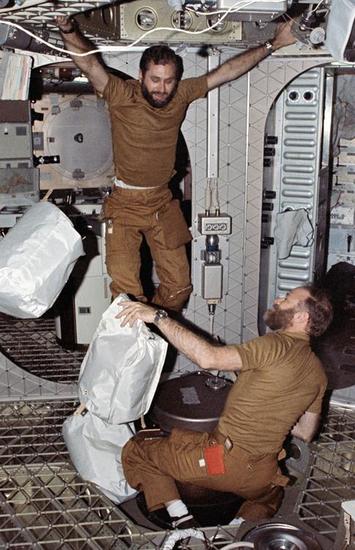  
*Bill Pogue (left) and Gerald Carr pass trash through an airlock to Skylab's waste disposal tank*

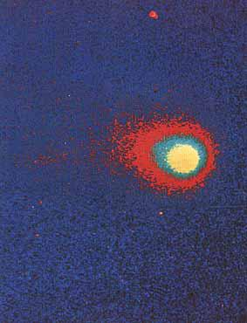  
*False color image of Comet Kohoutek photographed with the far-ultraviolet electrographic camera during a Skylab spacewalk on December 25, 1973.*

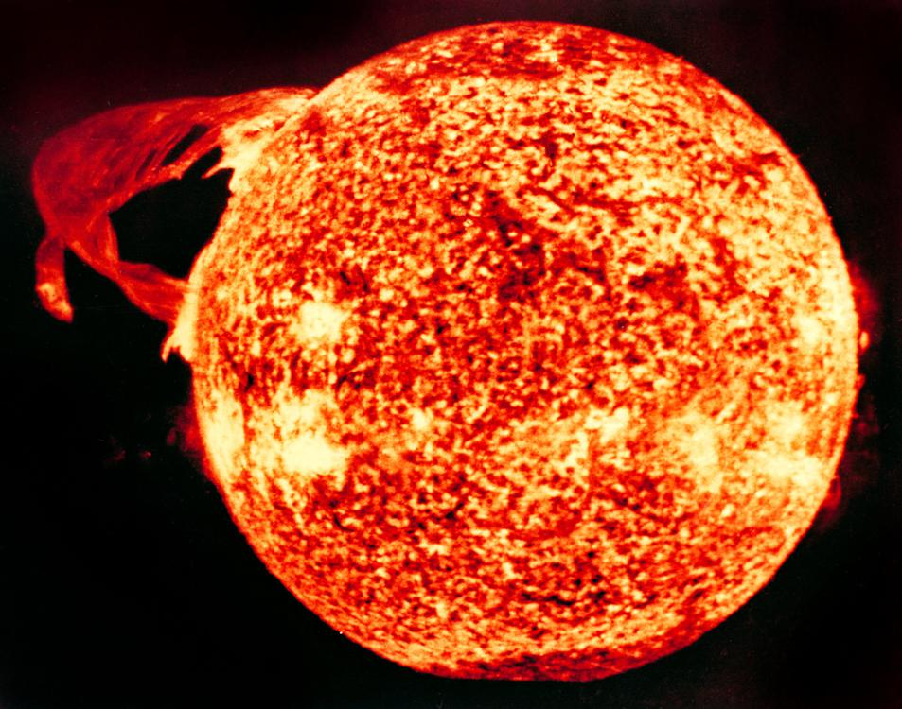  
*Solar prominence photographed December 19, 1973 by the Apollo Telescope Mount*

# Mission highlights

* *Ultimately none of the crew of Skylab 4 flew in space again, as none of the three had been selected for Apollo-Soyuz and all of them retired from NASA before the first Space Shuttle launch.*
* *Apart from the controversies, Skylab 4 was noted for several important science contributions.*
* *Skylab 4 was the last Skylab mission, the station fell from orbit in 1979.*

The all-rookie astronaut crew arrived aboard Skylab to find that they had company – three figures dressed in flight suits. Upon closer inspection, they found their companions were three dummies, complete with Skylab 4 mission emblems and name tags which had been left there by Al Bean, Jack Lousma, and Owen Garriott at the end of Skylab 3.

Things got off to a bad start after the crew attempted to hide Pogue's early space sickness from flight surgeons, a fact discovered by mission controllers after downloading onboard voice recordings. Astronaut office chief Alan B. Shepard reprimanded them for this omission, saying they "had made a fairly serious error in judgement."

The crew had problems adjusting to the same workload level as their predecessors when activating the workshop. The crew's initial task of unloading and stowing the thousands of items needed for their lengthy mission also proved to be overwhelming. The schedule for the activation sequence dictated lengthy work periods with a large variety of tasks to be performed, and the crew soon found themselves tired and behind schedule.

Seven days into their mission, a problem developed in the Skylab gyroscopic attitude control system, which threatened to bring an early end to the mission. Skylab depended upon three large gyroscopes, sized so that any two of them could provide sufficient control and maneuver Skylab as desired. The third acted as a backup in the event of failure of one of the others. The gyroscope failure was attributed to insufficient lubrication. Later in the mission, a second gyroscope showed similar problems, but special temperature control and load reduction procedures kept the second one operating, and no further problems occurred.

On Thanksgiving Day, Gibson and Pogue accomplished a 6½ hour spacewalk. The first part of their spacewalk was spent deploying experiments and replacing film in the solar observatory. The remainder of the time was used to repair a malfunctioning antenna. During the experience, Gibson remarked, "Boy if this isn't the great outdoors! Inside, you're just looking out through a window. Here, you're right in it." The crew reported that the food was good, but slightly bland. The quantity and type of food consumed was rigidly controlled because of their strict diet. Although the crew would have preferred to use more condiments to enhance the taste of the food, and the amount of salt they could use was restricted for medical purposes, by the third mission the NASA kitchen had increased the availability of condiments, and salt and pepper was in liquid solutions (granular salt and pepper brought aboard by the second crew was little more than "air pollution").

On December 13, the crew sighted Comet Kohoutek and trained the solar observatory and hand-held cameras on it. They gathered spectra on it using the Far Ultraviolet Camera/Spectrograph. They continued to photograph it as it approached the Sun. On December 30, as it swept out from behind the Sun, Carr and Gibson spotted it as they were performing a spacewalk.

As Skylab work progressed, the astronauts complained of being pushed too hard, and ground controllers complained they weren't getting enough work done. NASA determined major contributing factors were a large number of new tasks added shortly before launch with little or no training, and searches for equipment out of place on the station. There was a radio conference to air frustrations which led to the workload schedule being modified, and by the end of their mission the crew had completed even more work than originally planned.

Apart from the controversies, Skylab 4 was noted for several important science contributions. The crew spent many hours studying the Earth. Carr and Pogue alternately manned controls, operating the sensing devices which measured and photographed selected features on the Earth's surface. Gibson and the other crew made solar observations, recording about 75,000 new telescopic images of the Sun. Images were taken in the X-ray, ultraviolet, and visible portions of the spectrum.

As the end of their mission drew closer, Gibson continued his watch of the solar surface.  
On January 21, 1974, an active region on the Sun's surface formed a bright spot which intensified and grew. Gibson quickly began filming the sequence as the bright spot erupted. This film was the first recording from space of the birth of a solar flare.

The crew also photographed the Earth from orbit. Despite instructions not to do so, the crew (perhaps inadvertently) photographed Area 51, causing a minor dispute between various government agencies as to whether the photographs showing this secret facility should be released. In the end, the picture was published along with all others in NASA's Skylab image archive, but remained unnoticed for years.

The Skylab 4 astronauts completed 1,214 Earth orbits and four EVAs totaling 22 hours, 13 minutes. They traveled 34.5 million miles (55,500,000 km) in 84 days, 1 hour and 16 minutes in space. Skylab 4 was the last Skylab mission, the station fell from orbit in 1979.

The three astronauts had joined NASA in the mid-1960s, during the Apollo program, with Pogue and Carr becoming part of the likely crew for the cancelled Apollo 19. Ultimately none of the crew of Skylab 4 flew in space again, as none of the three had been selected for Apollo-Soyuz and all of them retired from NASA before the first Space Shuttle launch. Gibson, who had trained as a scientist-astronaut, resigned from NASA in December 1974 to do research on Skylab solar physics data, as a senior staff scientist with the Aerospace Corp. of Los Angeles, California.

# Gallery

# Command Module legacy

* *The Skylab 4 command module is in the collection of the National Air and Space Museum in Washington, D.C, and was transferred to the museum in 1975.*
* *The windows of the Skylab 3 and 4 spacecraft modules were studied for micrometeroid impacts.*
* *This module is the Command and Service Modules CSM-118 and it spent 84 days in Earth orbit as part of the Skylab mission.*

The Skylab 4 command module is in the collection of the National Air and Space Museum in Washington, D.C, and was transferred to the museum in 1975. This module is the Command and Service Modules CSM-118 and it spent 84 days in Earth orbit as part of the Skylab mission. As of 2018 it is not on display and is either on loan or in storage.

The module rolled upside down after splashdown, which happened in about half the Apollo CSM splashdowns; in this situation spheres were inflated on top of the CSM to right the module.

The windows of the Skylab 3 and 4 spacecraft modules were studied for micrometeroid impacts.

The module was painted white on half its side to help with spacecraft thermal management. Whereas Block II Apollo CSM had Kapton coated with aluminum and silicon monoxide, later Skylab modules had white paint for the sunward side.

# Mission insignia

* *It also relates to the Skylab medical studies of man himself.*

The triangular emblem features a large number 3 and a rainbow circling three areas of study the astronauts pursued. At the time of the flight, the astronauts issued the following description:

"The symbols in the patch refer to the three major areas of investigation in the mission. The tree represents man's natural environment and refers to the objective of advancing the study of earth resources. The hydrogen atom, as the basic building block of the universe, represents man's exploration of the physical world, his application of knowledge, and his development of technology. Since the sun is composed primarily of hydrogen, the hydrogen symbol also refers to the Solar Physics mission objectives. The human silhouette represents mankind and the human capacity to direct technology with a wisdom tempered by his regard for his natural environment. It also relates to the Skylab medical studies of man himself. The rainbow, adopted from the Biblical story of the Flood, symbolizes the promise that is offered to man. It embraces man and extends to the tree and hydrogen atom, emphasizing man's pivotal role in the conciliation of technology with nature by a humanistic application of our scientific knowledge."

Some versions of the patch included a comet in the top curve because of studies made of the comet Kohoutek.

# See also

* *List of spacewalks*
* *Extra-vehicular activity*
* *Splashdown (spacecraft landing)*
* *Timeline of longest spaceflights*

Extra-vehicular activity

List of spacewalks

Splashdown (spacecraft landing)

Timeline of longest spaceflights

# References

# Further reading

* *Gilles Clement, Fundamentals of Space Medicine, Microcosm Press, 2003. pp.*

Gilles Clement, Fundamentals of Space Medicine, Microcosm Press, 2003. pp. 212.

Lattimer, Dick (1985). All We Did was Fly to the Moon. Whispering Eagle Press. ISBN 0-9611228-0-3.

# External links

* *Skylab Saturn 1B flight manual (PDF) September 1972*
* *Marshall Space Flight Center Skylab Summary*
* *Skylab, "The Third Manned Period", NASA History (History.nasa.gov )*
* *NASA Skylab Chronology*
* *Skylab 4 Characteristics SP-4012 NASA HISTORICAL DATA BOOK*
* *Astronauts and Area 51: the Skylab Incident*

Skylab: Command service module systems handbook, CSM 116 – 119 (PDF) April 1972

Skylab Saturn 1B flight manual (PDF) September 1972

NASA Skylab Chronology

Marshall Space Flight Center Skylab Summary

Skylab 4 Characteristics SP-4012 NASA HISTORICAL DATA BOOK

Astronauts and Area 51: the Skylab Incident

Skylab, "The Third Manned Period", NASA History (History.nasa.gov )

Voices of Oklahoma interview with William Pogue. First person interview conducted with William Pogue on August 8, 2012. Original audio and transcript archived with Voices of Oklahoma oral history project.